**IBM Data Science Capstone Project**

**Data Section**

London Underground, commonly referred to as the Tube, is the heart of the transportation system of the city of London. So, the location of the tube stations provides information about the footfall as well as the connectivity of the surrounding areas. For the clustering problem the below Wikipedia web page is scrapped and the corresponding data is extracted.

<https://wiki.openstreetmap.org/wiki/List_of_London_Underground_stations>

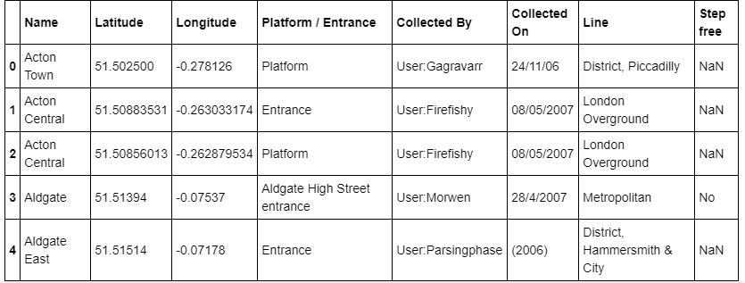

Moreover the Foursquare API to explore venue types surrounding each station is also used. Venues having a walk able distance of approximately 500 metres is explored using Foursquare . A screenshot of the foursquare url is as follows:

